Jules MINGUET

**Fourth year student of EPITECH Montpellier**

**Studying at Monash in exchange for 1 year**

**French Student looking for a job 1 year**

CONTACT

C:\Users\HOME\AppData\Local\Microsoft\Windows\Temporary Internet Files\Content.IE5\UXL89T6S\Home_icon_black[1].png

## 38 College Walk, Clayton 3168 VIC, Australia

C:\Users\HOME\AppData\Local\Microsoft\Windows\Temporary Internet Files\Content.IE5\UXL89T6S\1024px-Aiga_mail.svg[1].png

[jul.minguet@gmail.com](mailto:jul.minguet@gmail.com)

C:\Users\HOME\AppData\Local\Microsoft\Windows\Temporary Internet Files\Content.IE5\HSY1BAV6\6xqFT[1].png

## +336 95 91 15 72

Hrothgor

## Hrothgor.github.io

ABOUT ME

# Training

### 2019 - 2022

3 years at EPITECH Montpellier (Learning and deepening the language C, C++, Haskell, Unity)

### 2018 - 2019

Preparatory class for the Grandes Ecoles, PC series at the Joffre high school in Montpellier

### 2018

Last year of High Scholl series S Option ISN (Initiation to Digital Sciences) at Joffre high school in Montpellier.. Baccalauréat with Honors

# Experiences

*2022 - 2023 – Monash, Clayton Australia*

* ‘*Game Design’* and *‘Game Programming’* units, working 2 different games on Unreal.

One is a Multiplayer game TPS and the other is a multiplayer smash bro like.

* ‘*Algorithm and Data Structure’* unit, learning how to optimize algorithm and working behind a certain Big O notation (for sort or pathfinding for example)

*2019 - 2022 -* EPITECH Montpellier (private computer school)

* Multiple development projects in C, C++, Haskell as part of my training (linux, mathematics, graphics, etc.). See Github account.
* Multiple Graphic-oriented personal project. See portfolio.
* Realization of my own graphic engine in OpenGl that I reuse in my graphic projects.

## *2020 -* Septeo Genapi (4-month internship from September to December)

* Progress on the Talent project. Back (C#), Front (HTML CSS et TS), DB (SQL)
* Tutor: Mathieu Gury
* Agile method practiced within a team of 9 members.

Skills

## Professional

Relational

Communication

Team spirit

Rigorous

## Technological

|  |
| --- |
| **22 years. Single** |
| **Driving license B** |
| **Sports practiced** |
| Hand-Ball (Championnat  départemental Sénior) Snowboard  **Hobbies**  Video games |

C++

GLSL

C

Haskell

# Languages

C#

SQL Linux

Unreal

Unity

Python

OpenGL

Assembly

English Spanish French

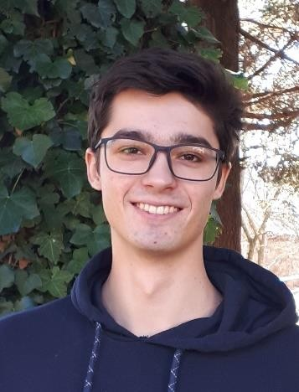

Spoken, Read and Understood (850 equivalent TOIC) Read and Understood

Native language